Christopher Smith

December 1, 2020

CIS 4339

Final Project – Technical Document

**Project Idea**

The idea for the project is a subscription box web application entitled “TechCrate Collectors”. The concept of TechCrate Collectors is a subscription box company built around the theme of technology, with its monthly boxes featuring different gadgets, hardware, gift cards, merchandise, etc. Subscription boxes are growing trend with companies promoting various themes such as technology, sports, beauty, childcare, food, pop culture, etc.. Additionally, with the COVID-19 pandemic in place it gives an opportunity to receive a package of desired items at a convenient price without necessarily having to go to stores to search.

**Search Criteria Screenshots**

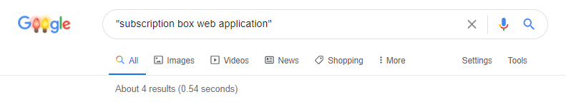

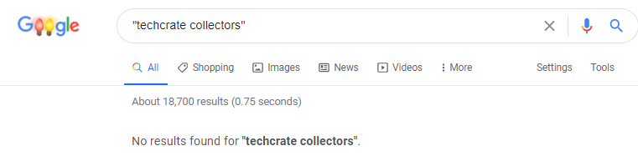

**Performance**

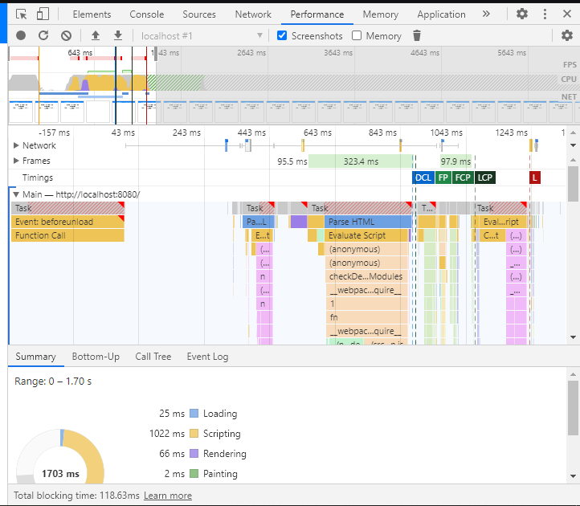

**Dependencies**

For this application, I used a variety of dependencies on the client and server level that include:

* Client
  + [NPM install -g @vue/cli](https://www.npmjs.com/package/@vue/cli?activeTab=versions)
    - Command to install Vue CLI, which is the standard tooling for Vue.js development. Vue.js is an open-source model-view-viewmodel front-end JavaScript framework for building user interfaces and single page applications.
  + [NPM install bootstrap](https://www.npmjs.com/package/bootstrap)
    - Command to install Bootstrap. Bootstrap is a free and open source CSS framework directed at responsive, mobile-first front-end web development.
  + [NPM install axios](https://www.npmjs.com/package/axios)
    - Command to install Axios. Axios is a promise based HTTP client for web browsers and Node.js.
* Server
  + [Npm init -y](https://www.npmjs.com/package/init-package-json)
    - Command to get node modules started.
  + [Npm install body-parser](https://www.npmjs.com/package/body-parser)
    - Command to install Body-Parser, which is a Node.js body-parsing middleware.
  + [NPM install cors](https://www.npmjs.com/package/cors)
    - Command to install CORS, which is a Node.js package for providing a Connect/Express middleware that can be used to enable CORS with various options.
  + [NPM install express](https://www.npmjs.com/package/express)
    - Command to install Express, which is a Fast, unopinionated, minimalist web framework for node.
  + [NPM install mongoose](https://www.npmjs.com/package/mongoose)
    - Command to install Mongoose, which is a MongoDB object modeling tool designed to work in an asynchronous environment.
  + [NPM install nodemon](https://www.npmjs.com/package/nodemon)
    - Command to install Nodemon, which helps develop Node.js applications by automatically restarting the node application when file changes in the directory are detected.

**Startup**

To ensure that the application works properly, there’s a set of steps to be taken.

* If not already in place, install MongoDB
* In MongoDB Compass or an equivalent software, create a database entitled “project”. Then create a collection called “subscribers”
* Once in Visual Studio Code, ensure that the necessary dependencies have been installed in the correct locations.
* From there, maneuver to the Terminal tab, and create a new one.
* Once the terminal is up, move to the folder where MongoDB is located on your device. For example, the command for me is “cd C:\Program Files\MongoDB\Server\4.4\bin”.
* Once that folder is active, type “mongo” to active MongoDB.
* Next, keep that terminal running and add a second one. In this one type “cd server” to maneuver to that folder. Once active, type “node app.js” to launch.
* Next, also keep that terminal running and add a third terminal. In this one type “cd client” to maneuver to that folder. Once active, type “npm run serve” to launch.
* Once the final terminal is running, click the local host link (should be port 8080) and to launch the website in your web browser of choice.
* Once inside the browser, you can navigate to the “Sign-Up” page to **Create** a new subscriber. Or you can go to the “View Subscribers” page to **Read, Update** or **Delete.**
* You can navigate to the “FAQ” page to view the Frequently Asked Questions section.

Below, is an example screenshot of a what a filled out sign-up form looks like

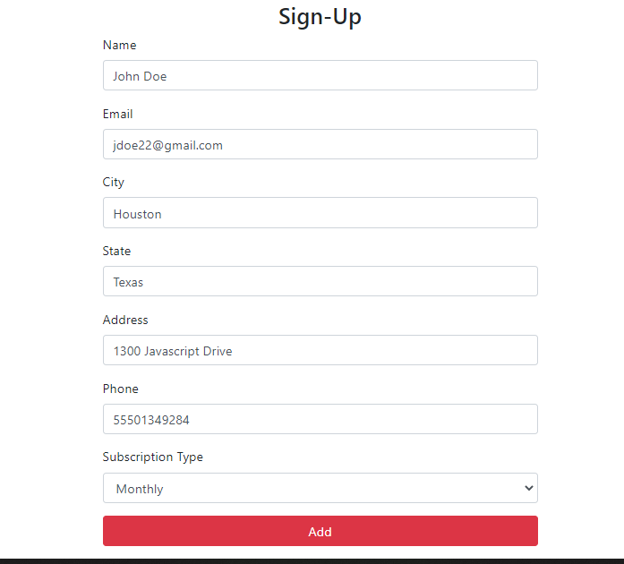

**References**

* CIS 4339 Lectures
* Error Help: Stack-Overflow
  + <https://stackoverflow.com/questions/52572852/deprecationwarning-collection-findandmodify-is-deprecated-use-findoneandupdate>
  + <https://stackoverflow.com/questions/51770772/mongoose-connect-first-argument-should-be-string-received-undefined>
  + <https://stackoverflow.com/questions/13312358/mongo-couldnt-connect-to-server-127-0-0-127017>
* MEVN Full Stack Tutorial: YouTube
  + <https://www.youtube.com/watch?v=vr6O-IYebXA>